Halo Emergency Ring Reserve Spine
White Paper Proof of Concept for Distributed Ring Reserve, Energy Distribution, and Spectral Overcharge Hold
Document Type | Emergency continuity-power and reserve-distribution proof-of-concept white paper
Concept Thesis | Wrap spinning PTEC nodes around the Halo spine as a circulating reserve layer, use the spine as the segmented routing backbone, and include Spectral Overdrive Cells as overcharge-hold modules for emergency backup systems.
Primary Use | Critical-load continuity, energy distribution, overcharge holding, local survivability, and graceful fallback after main-plant failure
Status | High-level emergency reserve architecture draft
Abstract
Halo Emergency Ring Reserve Spine is a backup-power architecture that combines three linked ideas: a Halo spine that acts as the protected routing trunk, a circular ring of synchronized PTEC nodes that keeps reserve energy circulating and balanced around the ship, and Spectral Overdrive Cells that hold temporary overcharge so emergency loads can be supported when the main plant is degraded or offline. The concept does not claim that rotation alone creates power. Instead, it treats the ring as a reserve manifold, the spine as the distribution backbone, and the overdrive cells as the hold-and-release layer that preserves scarce energy for critical systems. In this framing, the ship fails more gracefully because backup energy can circulate, be redistributed, and be held for the moments that matter most.
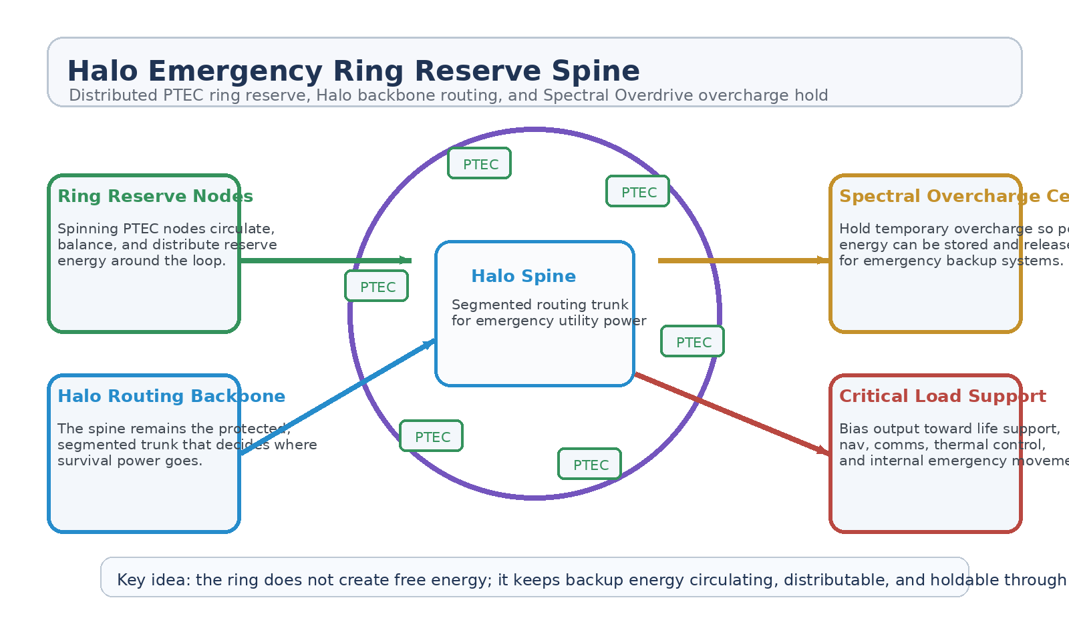
Figure 1. Halo Emergency Ring Reserve Spine with distributed PTEC reserve nodes, Halo routing trunk, Spectral Overdrive overcharge hold, and critical-load distribution.
1. Concept Thesis
The core idea is to turn the spine into more than a transit corridor and turn the PTEC ring into more than a field manifold. Together they become a backup circulation architecture. The spine routes survival energy through segmented internal domains, the ring keeps that energy moving and balanced, and Spectral Overdrive Cells provide a way to capture and hold temporary overcharge so it is available for emergency demand rather than wasted in a transient spike.
This is strongest when treated as a reserve-distribution doctrine rather than a free-energy claim.
2. Why the Combined Concepts Fit
Halo Transit Spine already provides the right routing backbone because it is segmented, fault-isolatable, and designed for graceful fallback. Halo Transit Spine v2 adds the idea that pulse-capable nodes can inject controlled authority without replacing the backbone itself. Halo PTEC Ring Field Spine adds the key ring logic: continuous circulation, sector balancing, and distributed node feeds. Spectral Overdrive Cells complete the picture by acting as temporary overcharge-hold modules so excess energy can be caught, remembered, and released later for backup loads.
• The spine gives the ship a protected internal utility path.
• The ring removes the dead-end behavior of a single-point backup bus.
• Distributed PTEC nodes balance reserve energy around the loop.
• Spectral Overdrive Cells hold temporary overcharge for later emergency use.
3. System Architecture
Layer | Subsystem | Primary Function | Emergency Role
L1 | Halo Spine Backbone | Provide segmented protected routing through the ship interior. | Continuity trunk
L2 | PTEC Ring Reserve Nodes | Circulate, balance, and redistribute reserve energy around the loop. | Distributed reserve layer
L3 | Field Circulation Layer | Keep reserve energy moving rather than terminating at one point. | Whole-ship balancing
L4 | Spectral Overdrive Cells | Capture temporary overcharge and hold it for emergency release. | Overcharge reserve hold
L5 | Priority Load Bus | Deliver emergency power to critical systems before nonessential loads. | Selective survivability

3.1 Ringed PTEC Reserve Layer
The spinning or synchronized PTEC nodes are strongest here when treated as reserve-circulation points. Their job is to keep backup energy balanced and available around the ship rather than letting emergency support depend on a single vulnerable bank or feed point.
3.2 Halo Spine as Distribution Trunk
The Halo spine remains the backbone. It decides which sections stay energized, which faults are isolated, and which critical loads receive continuity power first. This makes the reserve system useful because circulation without routing discipline is only noise.
3.3 Spectral Overdrive Overcharge Hold
Spectral Overdrive Cells are best interpreted here as temporary overcharge-hold modules. When the ring or other ship systems experience short periods of excess available energy, those cells capture and retain the spike so it can later be released into emergency backup systems rather than dissipated or wasted. In that role, they become the memory of the reserve architecture.
4. What This Backup System Best Supports
• Life support and environmental control continuity.
• Navigation, comms, and command-network survival power.
• Thermal control and fault-isolation support.
• Emergency lighting and corridor continuity.
• Selective internal movement, medevac, or utility support through surviving spine sections.
5. Why This Is Stronger Than a Single Backup Bank
• Distributed reserve is harder to starve than a single-point battery picture.
• A ring architecture allows load balancing and sector reinforcement under asymmetric damage.
• The spine keeps routing disciplined and fault-tolerant.
• Spectral Overdrive Cells preserve temporary peaks instead of losing them.
• The ship degrades more gracefully instead of collapsing into immediate blackout.
6. Boundaries and Realism
Halo Emergency Ring Reserve Spine should be framed honestly as an emergency reserve and distribution architecture. It does not create free energy, and it does not eliminate the need for a real stored or recoverable source behind the backup layer. Its value lies in circulation, routing, and temporary overcharge retention. Those three traits together can make scarce energy more survivable and more useful after a major failure.
• Most credible as a continuity-power and reserve-distribution doctrine.
• Not a substitute for full primary generation.
• Still limited by real stored or recoverable energy sources.
• Best used to preserve critical systems and buy time under degraded conditions.
7. Operating Modes
Mode | Ring Behavior | Overcharge Behavior | Outcome
Reserve Hold | Ring remains synchronized and ready. | Spectral cells hold captured peaks in standby. | Emergency readiness
Continuity Feed | Ring circulates reserve toward damaged or priority sectors. | Cells release held overcharge to support sudden backup demand. | Critical systems stay alive
Compartment Survival | Ring biases power around faulted arcs. | Cells support isolated local loads where routing is limited. | Partial-ship survivability
Recovery Escort | Ring continues low-rate balancing under degraded conditions. | Remaining overcharge is rationed for comms, medevac, or thermal control. | Longer rescue window

8. Proof-of-Concept Build Path
Phase | Goal | Bench / Program Activity | Success Signal
P1 | Spine baseline | Demonstrate segmented low-power routing across a protected internal trunk. | Stable continuity path
P2 | Ring reserve demo | Show distributed node-to-node reserve circulation around a closed loop. | Whole-loop balancing
P3 | Overcharge hold | Integrate a Spectral-cell surrogate that captures and later releases temporary peaks. | Useful retained reserve
P4 | Priority bus test | Feed ranked emergency loads under degraded source conditions. | Correct load shedding and support
P5 | Failure comparison | Compare single-bank backup against ring-reserve plus overcharge-hold behavior. | Clear survivability advantage

9. Conclusion
Halo Emergency Ring Reserve Spine turns three separate ideas into one coherent backup architecture. The Halo spine routes survival power. The PTEC ring keeps reserve energy circulating and balanced. Spectral Overdrive Cells catch overcharge and hold it for emergency release. Together they do not replace the main plant; they make the ship much harder to starve when the main plant is wounded or gone.
As a white paper PoC, the concept is strongest as the reserve nervous system behind graceful failure: not infinite power, but smarter use of what remains.
Working one-line doctrine: Use the ring to keep reserve energy circulating, the spine to distribute it, and Spectral Overdrive Cells to hold overcharge for emergency backup systems.

